Avocado Machine Learning Project Python for Price Prediction

**Business Objective**

Hass avocados, a Mexico based company produces a variety of Avocados which are sold in the US. They have been having good success for the past several years and want to expand. For this, they want to build and assess a plausible model to predict the average price of Hass avocado to consider the expansion of different types of Avocado farms that are available for growing in other regions.

**Aim**

Forecast the prices of Avocado in the US

**Data**

The data comes directly from retailers’ cash registers based on the actual retail sales of Hass avocados.

* Data represents weekly retail scan data for National retail volume (units) and price from Apr 2015 to Mar 2018.
* The Average Price (of avocados) in the table reflects a per unit (per avocado) cost, even when multiple units (avocados) are sold in bags.
* The Product Lookup codes (PLU’s) in the table are only for Hass avocados. Other varieties of avocados (e.g. greenskins) are not included in this table.

Some relevant columns in the dataset:

1. Date - date of the observation
2. AveragePrice - average price of a single avocado
3. Type - conventional / organic
4. Region - region of the observation
5. Total Volume - Total number of avocados sold
6. 4046 - Total number of avocados with PLU 4046 sold
7. 4225 - Total number of avocados with PLU 4225 sold
8. 4770 - Total number of avocados with PLU 4770 sold
9. Total Bags – Total bags sold
10. Small/Large/XLarge Bags – Total bags sold by size

There are two types of avocados in the dataset as well as several different regions represented. This allows you to do all sorts of analysis for different areas of the United States, specific cities, or just the overall United States on either type of avocado. Our analysis will be focused on the complete dataset.

**Dataset** : <https://www.kaggle.com/neuromusic/avocado-prices#avocado.csv>

**Tech Stack**

* Language used : Python
* Libraries used : statmodels, pmdarima, fbprophet, scikit-learn

**Approach**

1. Data Preprocessing
   1. Check for missing values
   2. Label Encoding
   3. One hot encoding
2. Exploratory Data Analysis
   1. Identifying any overarching trend in data over time
   2. Identifying any repetitive, seasonal patterns in the data
3. Feature Engineering
   1. Creating new columns
4. Building Forecast models
   1. Linear Regression
   2. Random Forest Regressor
   3. XGB Regressor
   4. Facebook Prophet
   5. ARIMA
   6. SARIMAX
5. Evaluating Forecast models
   1. R-squared
   2. MAPE
   3. MAE
   4. Plots comprising the actual values, forecast and confidence intervals.

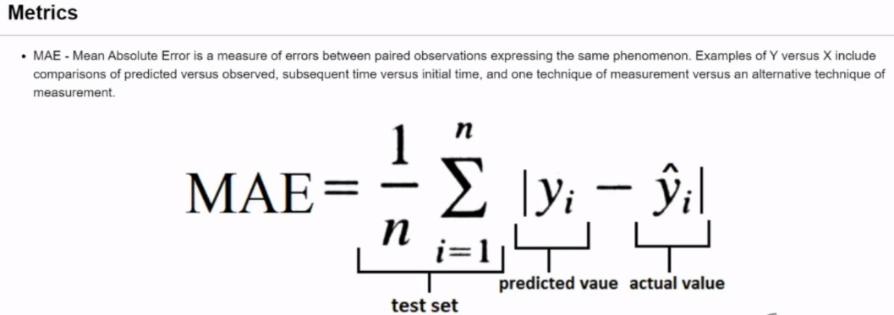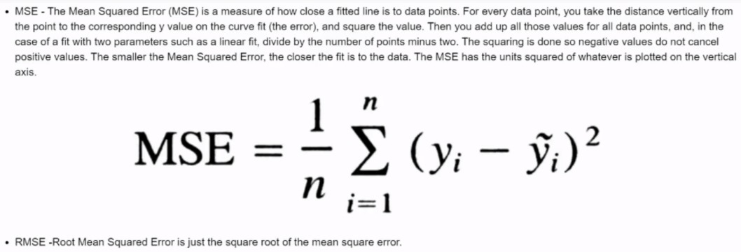

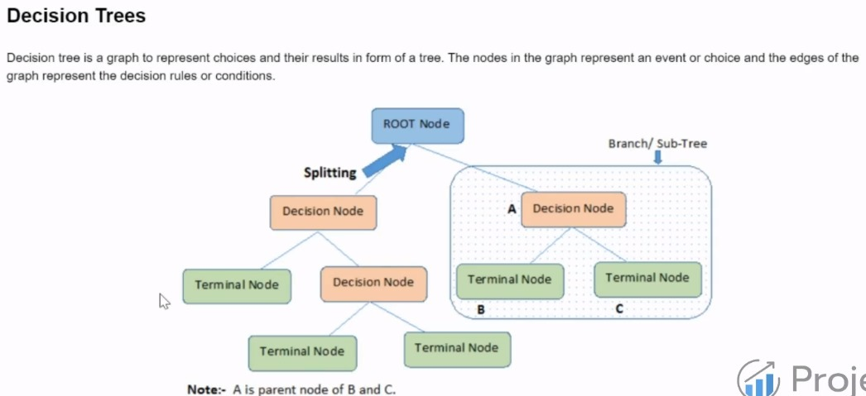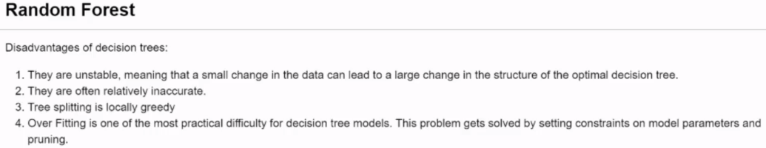

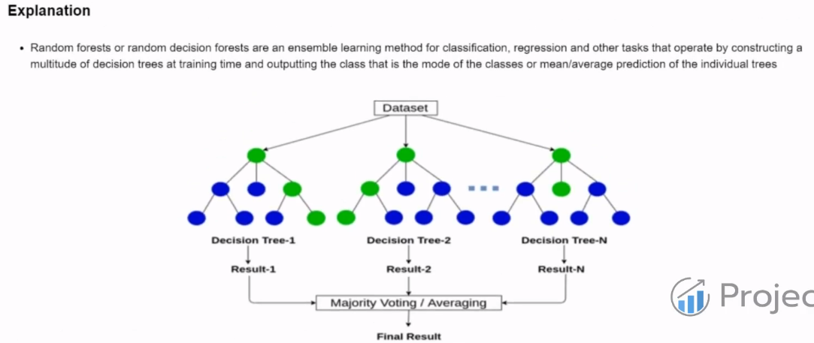

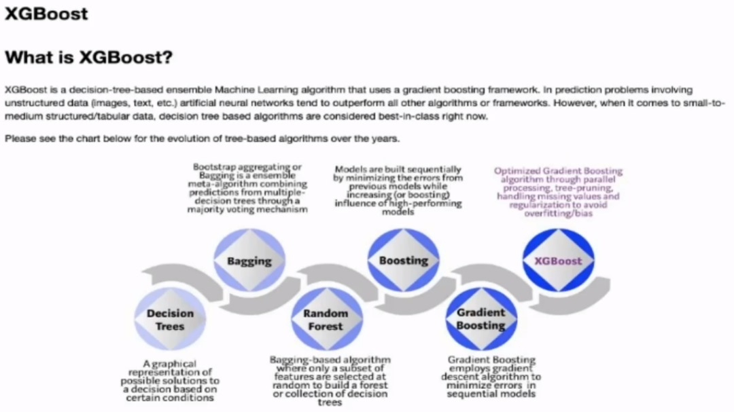

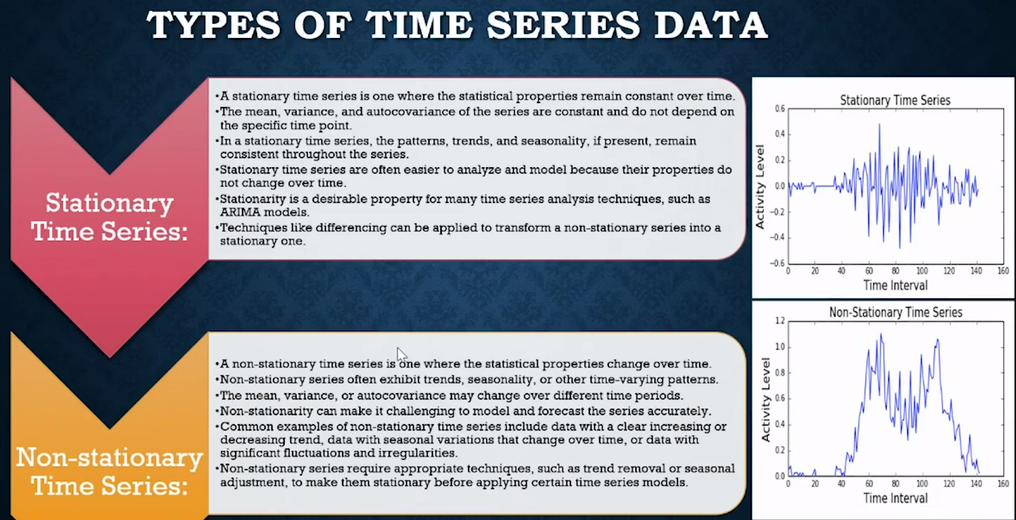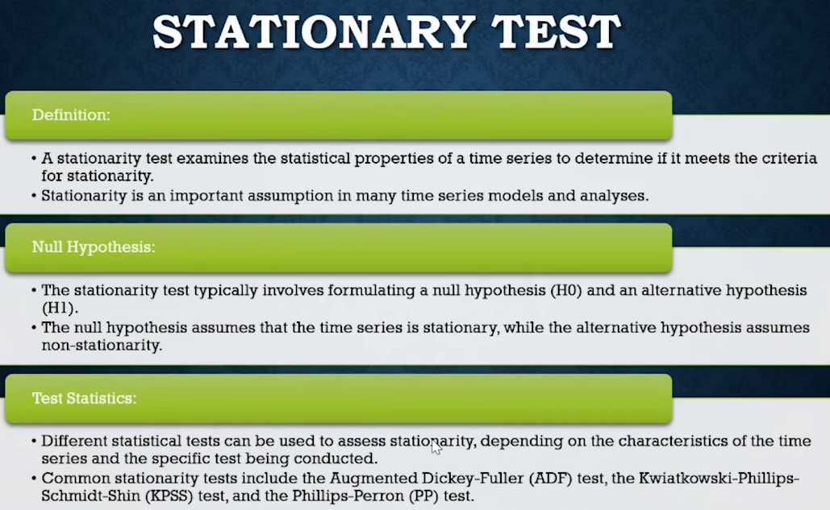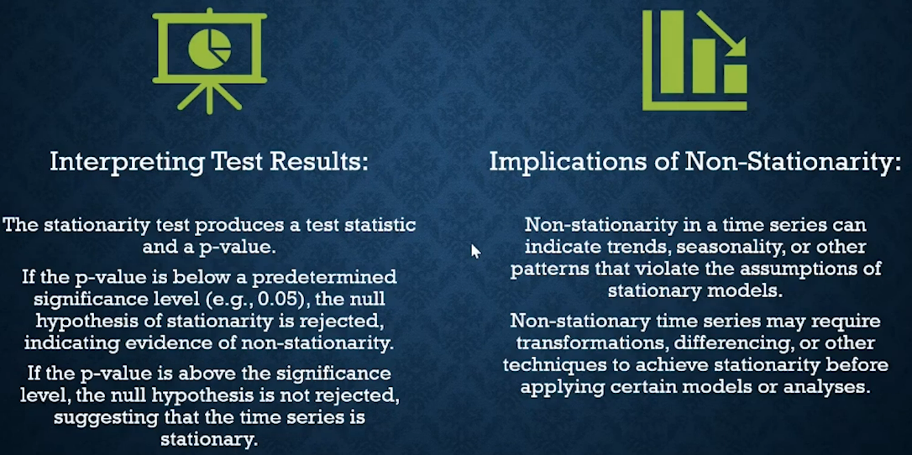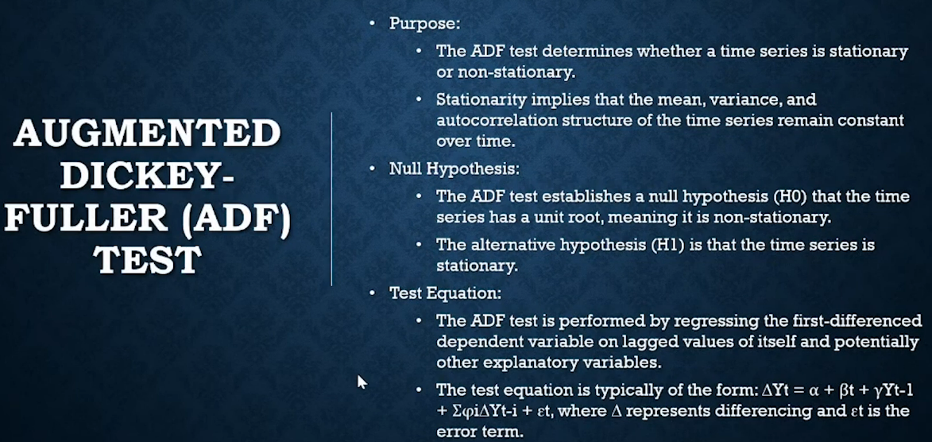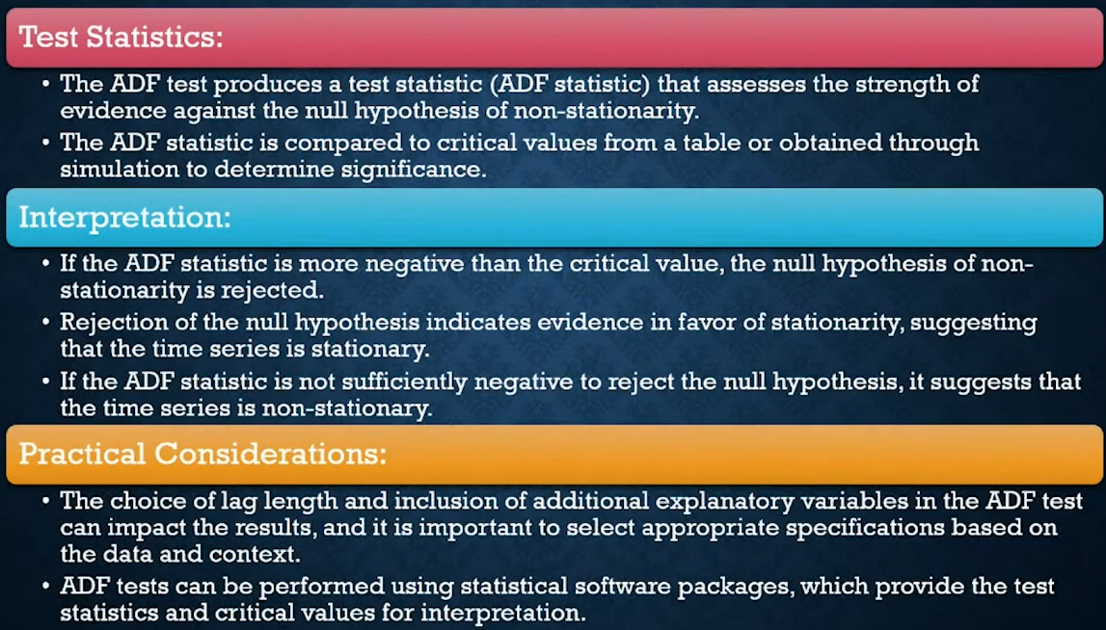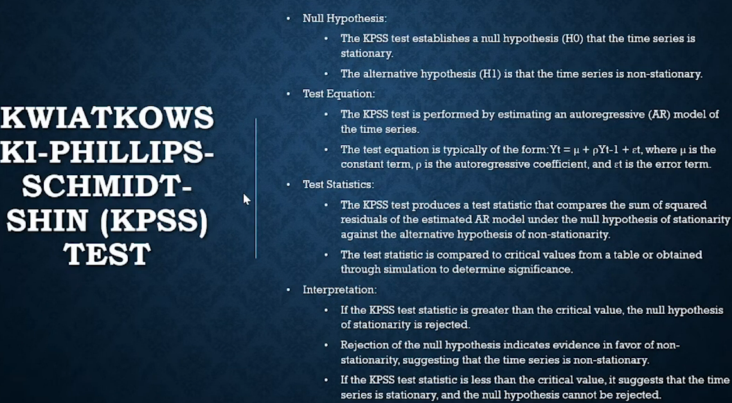

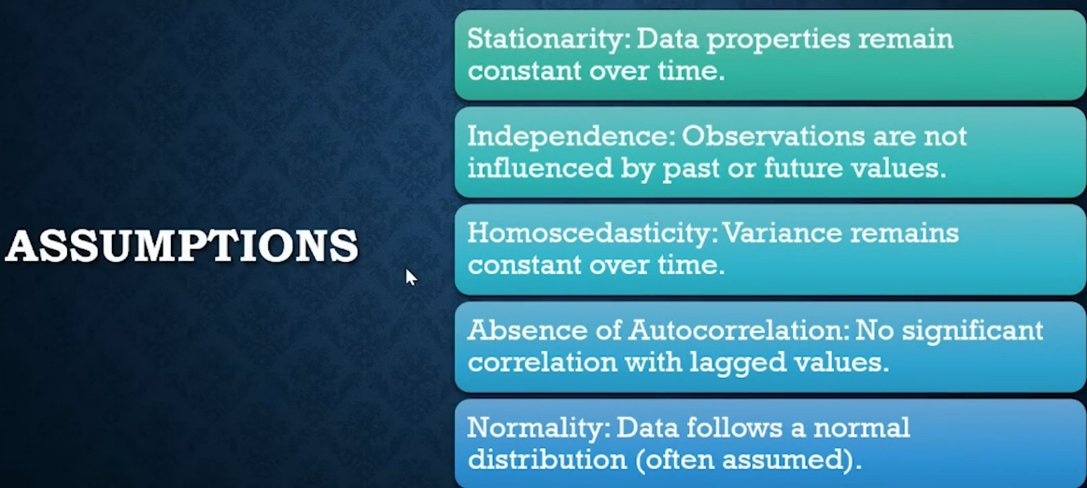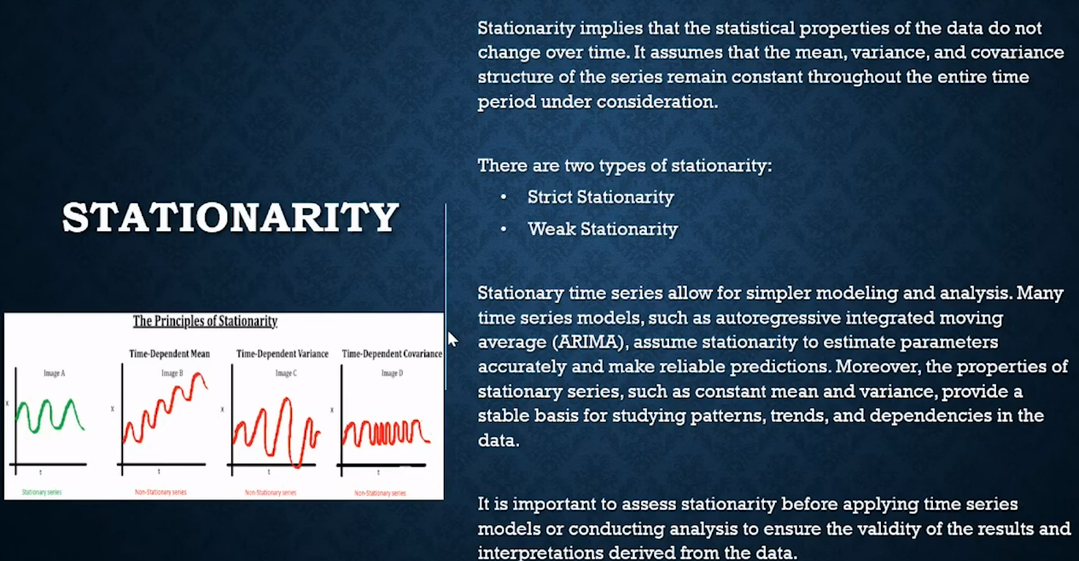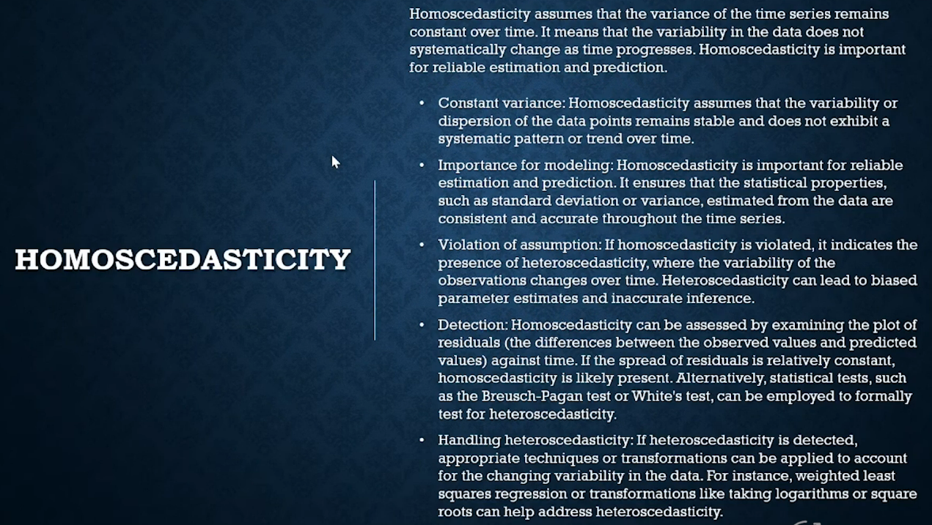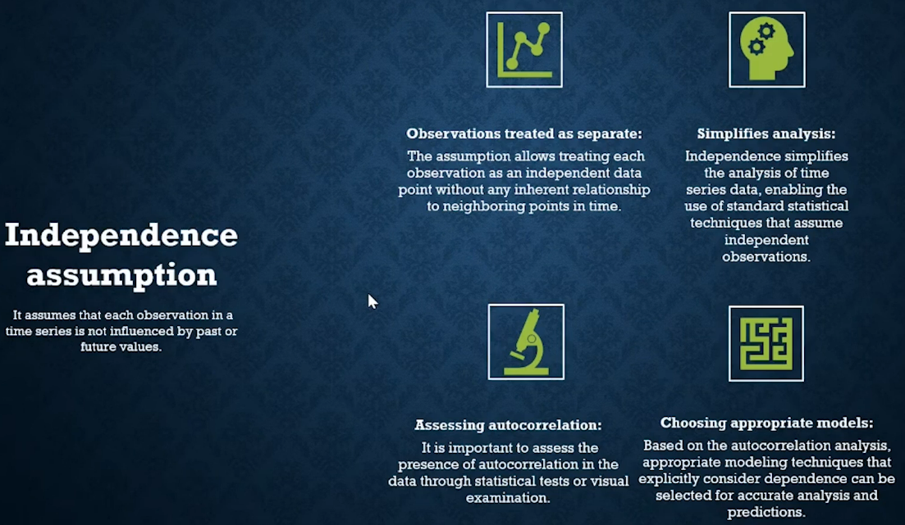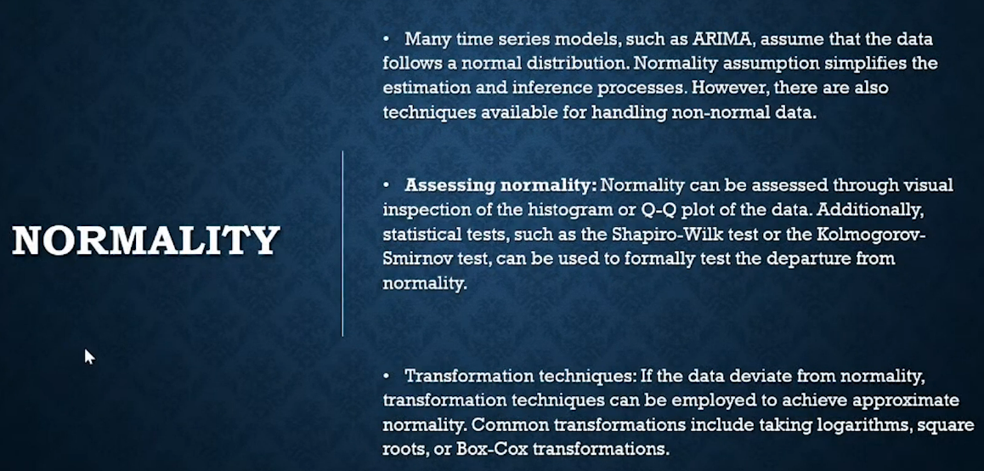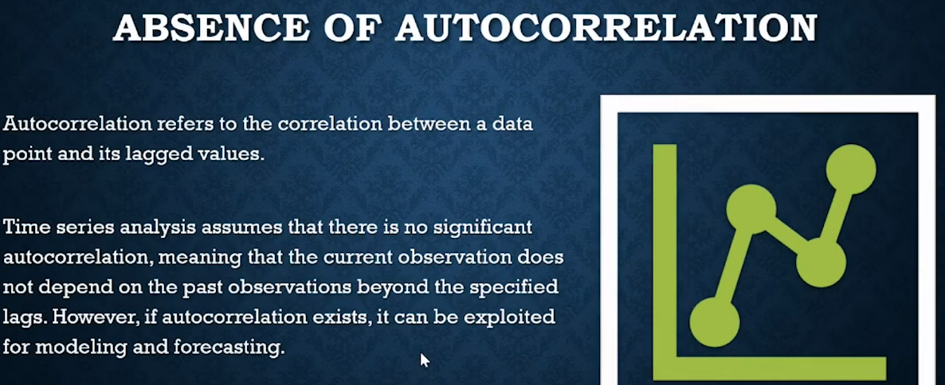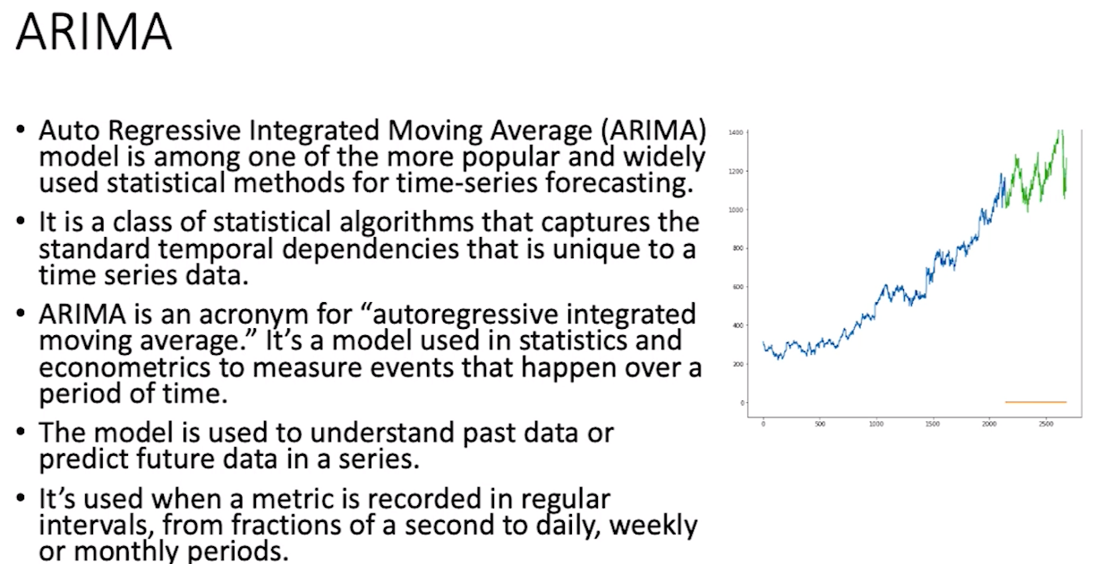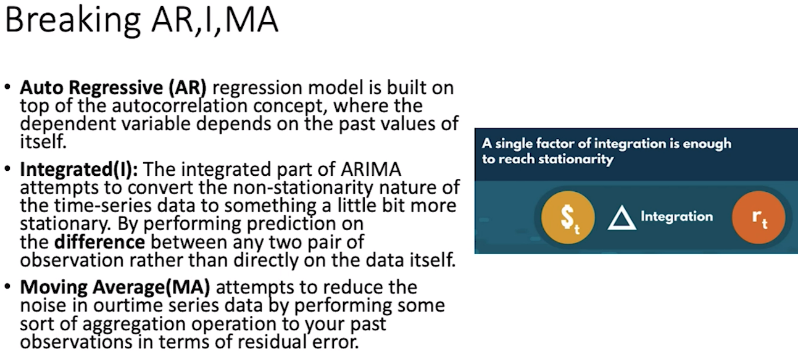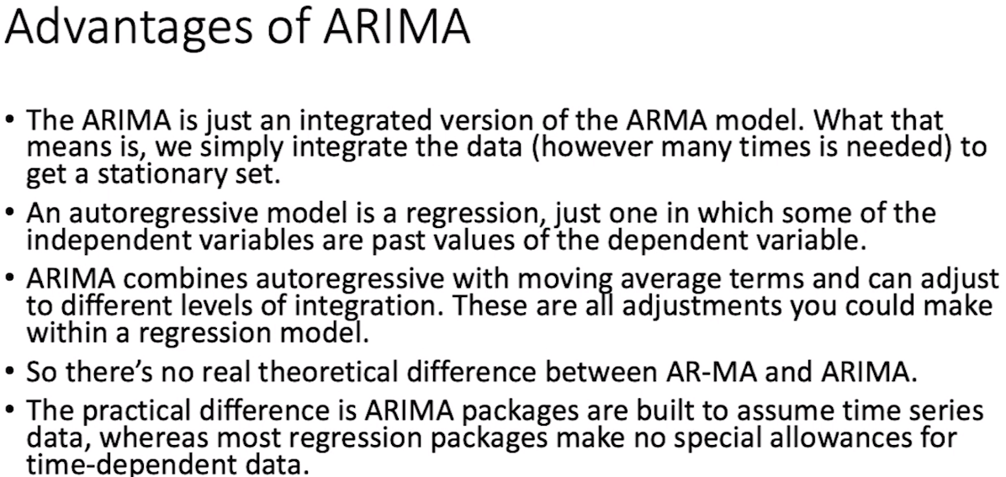

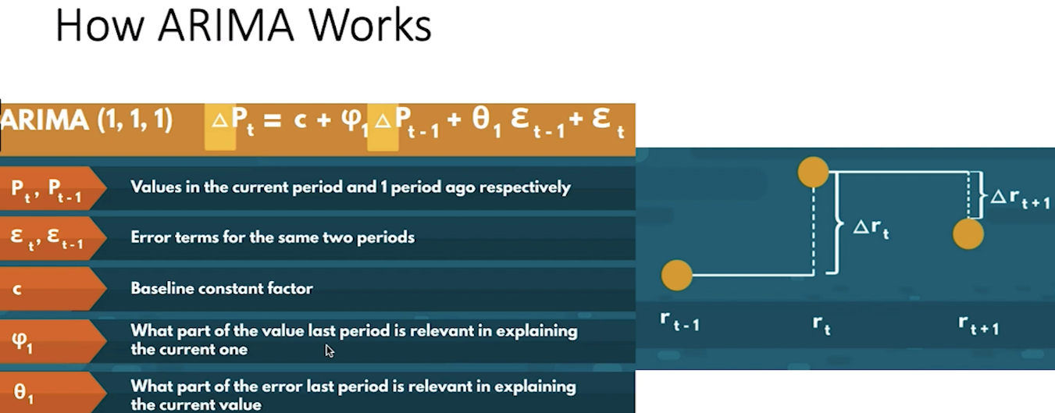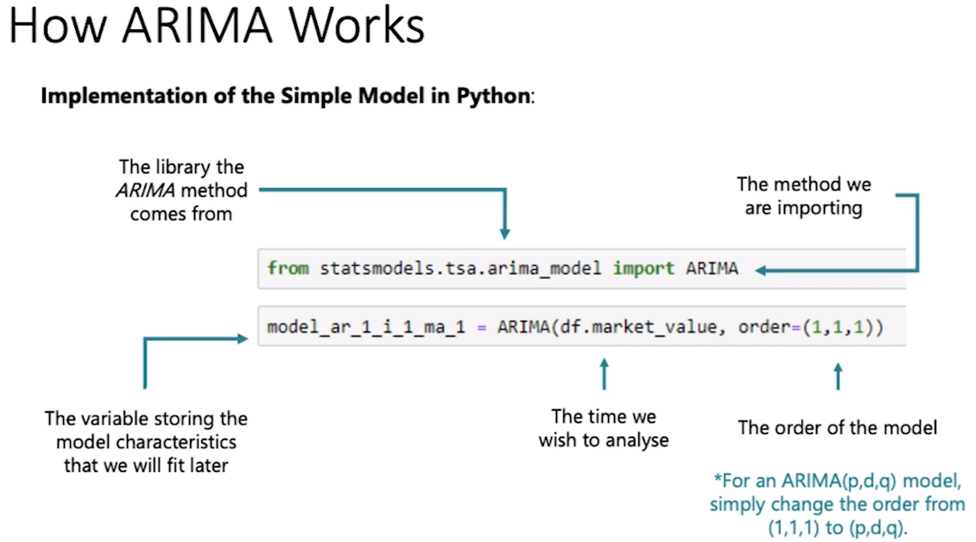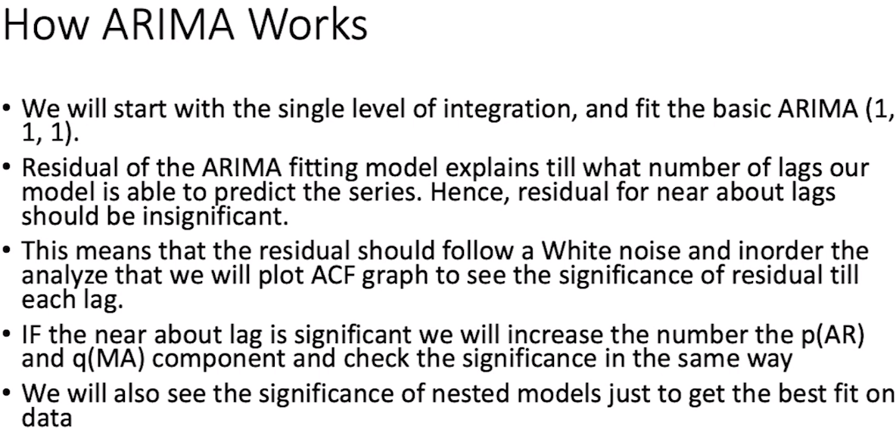

Bagging and Boosting are both ensemble techniques in machine learning to improve the accuracy, stability, and performance of machine learning algorithms, but they work in fundamentally different ways and are used in different scenarios. Here's a summary of the main differences:

**Bagging (Bootstrap Aggregating)**

* **Goal:** To reduce variance and prevent overfitting.
* **Method:** It works by creating multiple copies of the original training dataset using bootstrapping (sampling with replacement), training a separate model on each copy, and then combining the models by averaging the output (for regression) or voting (for classification).
* **Parallel Training:** The models are trained in parallel, as each model is independent of the others.
* **Example:** Random Forest is a classic example of bagging, where multiple decision trees are trained on different subsets of the data and combined to make the final prediction.

**Boosting**

* **Goal:** To reduce bias and variance, with a stronger emphasis on reducing bias.
* **Method:** It works by training a sequence of weak models, each compensating for the weaknesses of its predecessors. The training process weights instances that were incorrectly predicted by earlier models more heavily, making the next model focus more on difficult cases.
* **Sequential Training:** The models are trained sequentially, as each model depends on the previous ones.
* **Example:** Gradient Boosting Machines (GBMs) like XGBoost, LightGBM, and AdaBoost are examples of boosting, where models are added one at a time, and each new model corrects errors made by previous models.

**Key Differences**

* **Training Method:** Bagging trains models in parallel and independently, while boosting trains models sequentially and adaptively, focusing more on the errors of the previous model.
* **Objective:** Bagging aims primarily to reduce overfitting and variance without focusing much on bias, whereas boosting aims to reduce both bias and variance by focusing on correcting the errors of previous models.
* **Model Dependency:** In bagging, each model is built independently, making the method straightforward to parallelize. In contrast, boosting builds a new model based on the errors of previously built models, thus requiring sequential training.
* **Examples:** Random Forest (bagging) vs. XGBoost (boosting).

Both techniques are powerful and have their place in a machine learning practitioner's toolkit. The choice between bagging and boosting depends on the specific problem, the data at hand, and the type of errors you're trying to address in your predictive modeling task.

The choice between sequential training (as in boosting) and parallel training (as in bagging) involves considering several factors including computational resources, training time, model accuracy, and the nature of the dataset. Both approaches have their implications, advantages, and disadvantages. There isn't a one-size-fits-all answer to which is better; it depends on the specific context and requirements of your machine learning task. Let's delve into the implications of each:

**Sequential Training (Boosting)**

* **Sensitivity to Data:** Boosting sequentially focuses on difficult instances by reweighting them, which can lead to higher accuracy, especially when the data is imbalanced or when dealing with complex patterns that simple models (weak learners) struggle with.
* **Risk of Overfitting:** While boosting techniques generally aim to reduce both bias and variance, they can be more prone to overfitting compared to bagging, especially in the presence of noise in the data.
* **Computational Time:** Sequential training can be computationally more demanding and usually takes longer than parallel training, as each model must wait for the previous model to finish. This makes it less suitable for very large datasets or in scenarios where computational resources are limited.
* **Flexibility and Control:** Boosting allows for more flexibility and control over the learning process, as it adapts to the errors of the previous models, which can lead to better performance on complex problems.

**Parallel Training (Bagging)**

* **Scalability:** Parallel training is inherently more scalable and can be easily distributed across multiple processors or machines. This makes bagging methods like Random Forest more suitable for large datasets and parallel computing environments.
* **Reduced Overfitting:** By averaging multiple independent predictions, bagging effectively reduces variance without significantly increasing bias, which helps prevent overfitting, especially when the base models are complex (like deep decision trees).
* **Speed:** Since models can be trained in parallel, bagging can significantly reduce training time compared to sequential methods, assuming adequate computational resources are available.
* **Less Sensitivity to Outliers:** Bagging is generally less sensitive to outliers and noise in the data compared to boosting, as the aggregation of models tends to cancel out the noise.

**Which One is Better?**

* **It Depends on the Data and Problem:** Boosting might be more suitable for datasets where precision is crucial, and the data contains complex patterns that simpler models cannot capture. Bagging might be preferred when the dataset is very large, computational resources are a concern, or when the priority is to prevent overfitting.
* **Hybrid Approaches:** In practice, the choice is not always binary. Some advanced models and techniques draw on the strengths of both approaches, and the decision can involve using a combination or ensemble of different methods to achieve the best results.
* **Experimentation is Key:** Ultimately, the best approach is often determined through experimentation and cross-validation on the specific dataset you're working with. Model performance can vary greatly depending on the characteristics of the data and the task at hand.

In summary, neither sequential nor parallel training is universally "better"; they each have scenarios where they shine. The choice should be guided by the specific needs of your application, the nature of your data, and the computational resources at your disposal.

XGBoost (Extreme Gradient Boosting) is an efficient and scalable implementation of gradient boosting machines, a type of ensemble machine learning algorithm that is designed to improve prediction accuracy. XGBoost has gained popularity due to its speed and performance and is widely used in data science competitions and practical applications. Here's an overview of how XGBoost works:

**1. Gradient Boosting Framework**

XGBoost is built on the gradient boosting framework, which iteratively adds new models to an ensemble, with each new model correcting errors made by the previously combined ensemble of models. Specifically, XGBoost uses decision trees as base learners.

**2. Objective Function**

The objective function that XGBoost optimizes is composed of two parts: a loss function that measures how well the model predicts the target variable, and a regularization term that penalizes model complexity (number and depth of trees) to avoid overfitting. This makes XGBoost not just a boosting algorithm but also a regularized boosting technique.

**3. Gradient Boosting**

At each step, XGBoost builds a tree to predict the residuals or errors of the model. These residuals are the gradients of the loss function with respect to the predictions. The algorithm uses these gradients to decide how to construct the tree at each step, such as how to split the nodes.

**4. Tree Pruning**

XGBoost introduces a novel way of growing and pruning trees. Instead of growing trees greedily, XGBoost grows trees up to a specified maximum depth and then prunes back the splits that have the least importance. This approach is more effective and results in better performance.

**5. Regularization**

XGBoost incorporates L1 (Lasso regression) and L2 (Ridge regression) regularization terms in the objective function to control the complexity of the model. This regularization helps to prevent overfitting, which is a common problem with standard boosting methods.

**6. Handling Missing Values**

XGBoost has a built-in mechanism to handle missing values. When the model encounters a missing value at a split, it will try both directions (left and right child nodes) and choose the direction that results in the best split. This feature makes XGBoost robust to missing data.

**7. System Optimization**

XGBoost is designed for efficiency and scalability. It uses several system optimizations, such as:

* **Parallelization**: XGBoost parallelizes the construction of trees across multiple CPU cores during the training phase.
* **Cache Awareness**: The algorithm is designed to make efficient use of hardware resources, like cache memory, to speed up training.
* **Out-of-Core Computing**: XGBoost can handle very large datasets that do not fit into memory by spilling data to disk, making it highly scalable.

**8. Flexibility**

XGBoost can solve regression, classification, ranking, and user-defined prediction problems. It allows users to define custom optimization objectives and evaluation criteria, adding to its flexibility.

**Conclusion**

XGBoost works by combining multiple decision trees in a gradient boosting framework, with regularization to prevent overfitting and various system optimizations for speed and efficiency. Its effectiveness across a wide range of regression and classification problems, along with its scalability and flexibility, has made XGBoost a popular choice among data scientists.